**First you need to open the process level:**

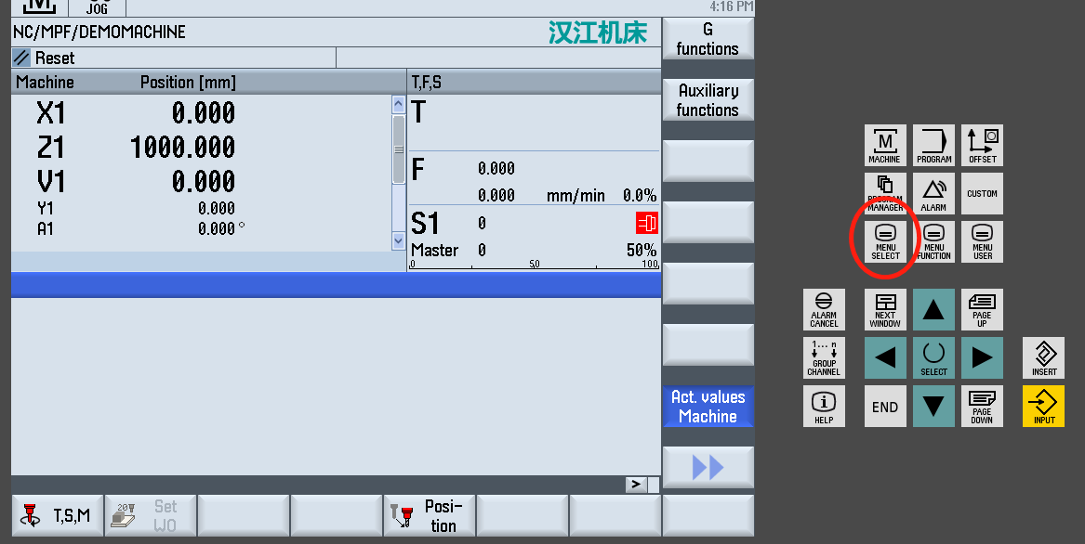

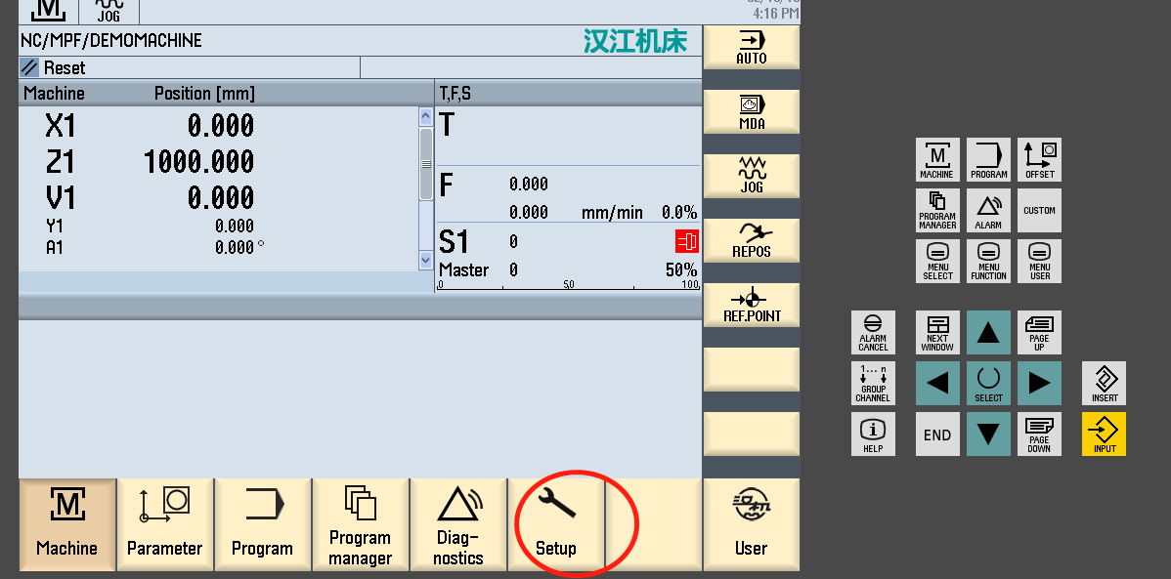

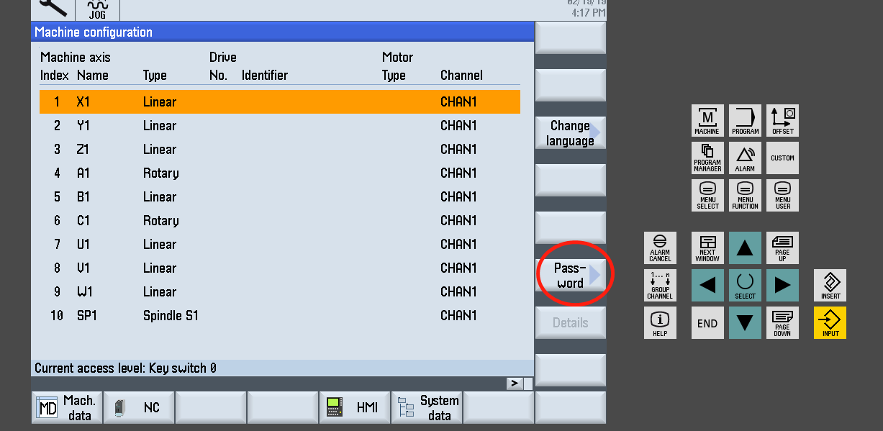

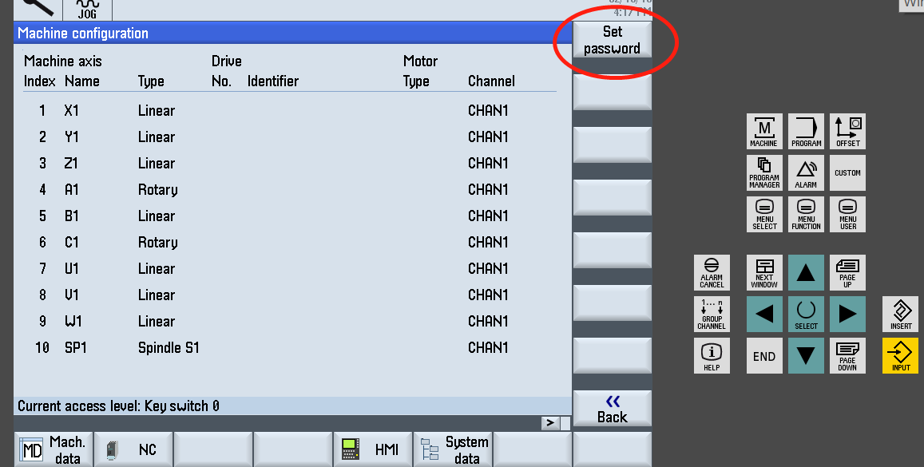

**The password is: HJJCLMSD**

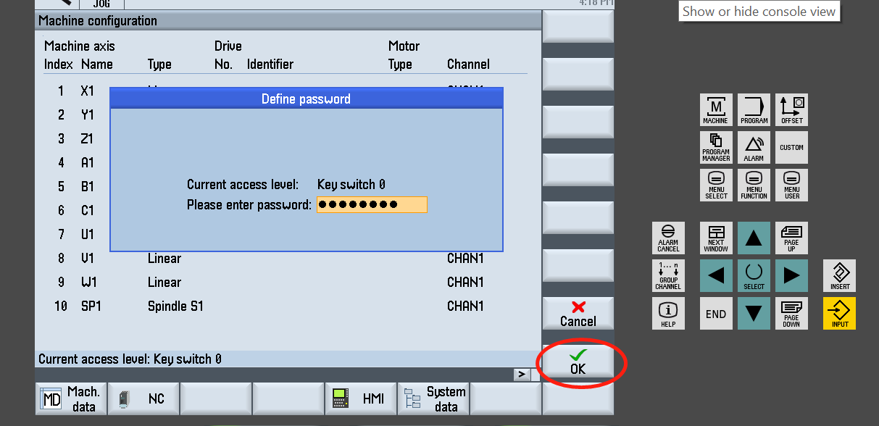

**If the access level is manufacturer then press system data:**

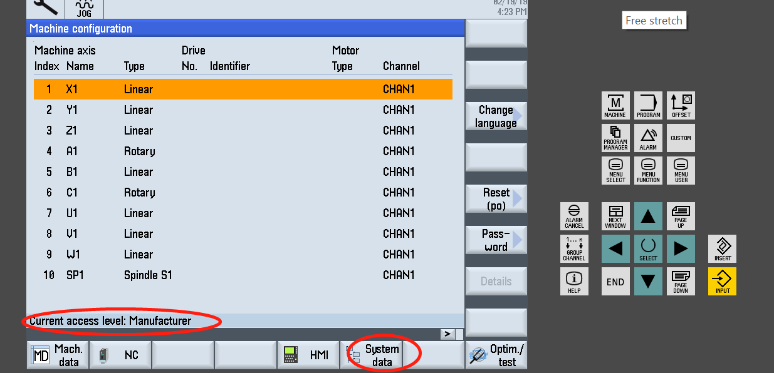

**Open nc data – cycles – manufacturer cycles and find “grinding_jump” and copy it to your USB disk: (as a backup)**

**Be aware copy the file in machine to you USB to other folder and do not cover the new “grinding_jump” file I sended to you.**

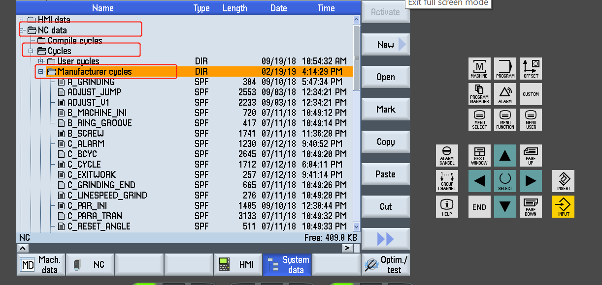

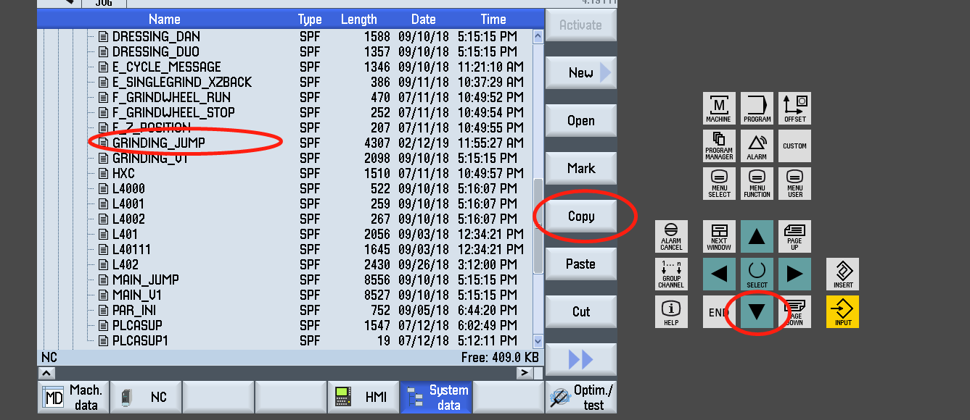

**Use left arrow to close the stacks:**

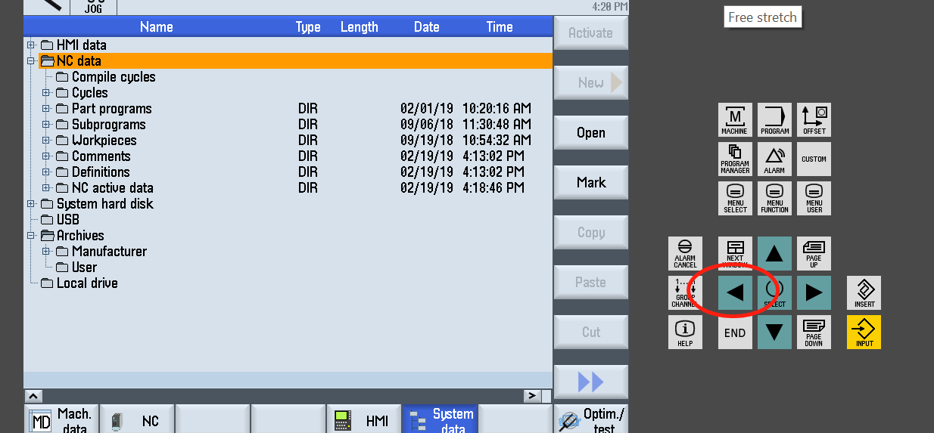

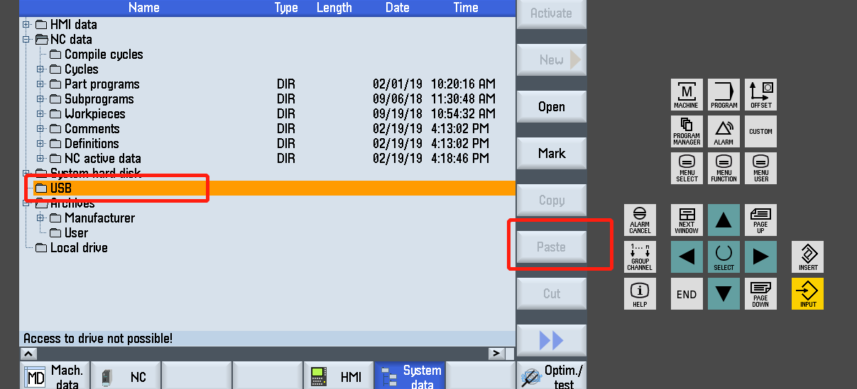

**Then copy the new file in your USB to the same place in machine: nc data - cycles – manufacturer cycles**

**Back to main page and you can do a test, be slow**

